**JIIT EHR**

**Minor Project II**

Submitted by:

**Priyanshi Rawat (9920103140)**

**Vedansh Sharma (9920103142)**

**Anandita Dua (9920103145)**

Under the supervision of :

**Dr. Shikha K Mehta**



**Department of CSE/IT**

**Jaypee Institute Of Information Technology University, Noida**

**April 2023**

**ACKNOWLEDGEMENT**

I would like to place on record my deep sense of gratitude to Dr. Shikha K Mehta , Associate Professor , Jaypee Institute of Information Technology, India for his/her generous guidance, help and useful suggestions.

I express my sincere gratitude to Dr. Raju Pal and Dr. Devpriya Soni, Dept. of CSE and IT, Noida, India, for his/her stimulating guidance, continuous encouragement and supervision throughout the course of present work.

I also wish to extend my thanks to other classmates for their insightful comments and constructive suggestions to improve the quality of this project work.

**Signature(s) of Student:**

Priyanshi Rawat (9920103140)

Vedansh Sharma (9920103142)

Anandita Dua (9920103145)

i

**DECLARATION**

We hereby declare that this submission is our own work and that, to the best of our knowledge and beliefs, it contains no material previously published or written by another person nor material which has been accepted for the award of any other degree or diploma from a university or other institute of higher learning, except where due acknowledgment has been made in the text.

Place: 201304, Noida, Uttar Pradesh, India

Date: 28-04-2023

Name: Priyanshi Rawat

Enrolment No.: 9920103140

Name: Vedansh Sharma

Enrolment No.: 9920103142

Name: Anandita Dua

Enrolment No.: 9920103145

ii

**CERTIFICATE**

This is to certify that the work titled “JIIT EHR” submitted by Priyanshi Rawat, Vedansh Sharma and Anandita Dua of B.Tech of Jaypee Institute of Information Technology, Noida has been carried out under my supervision. This work has not been submitted partially or wholly to any other University or Institute for the award of any other degree or diploma.

Digital Signature of Supervisor

Dr. Shikha K Mehta

Associate Professor

28-04-2023

iii

**ABSTRACT**

Blockchain have been an interesting research area for a long time and the benefits it provides have been used by a number of various industries. Similarly, the healthcare sector stands to benefit immensely from the blockchain technology due to security, privacy, confidentiality and decentralization. Our project aims to address the current challenges faced by the healthcare industry, such as inadequate data security, limited data accessibility, and low efficiency, by leveraging the decentralised and secure nature of blockchain technology.

The use of blockchain technology would not only provide better data security and integrity, but it would also improve the efficiency of data sharing between healthcare providers, leading to better patient outcomes. With a decentralised and easily accessible database of medical records, healthcare providers would have real-time access to a patient's medical history, allowing for more informed decision-making and can provide better patient care and improve the overall patient experience. In conclusion, the proposed blockchain application for managing health records has the potential to revolutionise the healthcare industry and improve the overall experience.

iv

**TABLE OF CONTENTS**

**Title Page No.**

*Acknowledgement i*

*Declaration ii*

*Certificate iii*

*Abstract iv*

*List of Figures vi*

**Chapter 1: INTRODUCTION** 1

1.1 General Introduction 1

1.2 Problem Statement 1

**Chapter 2: BACKGROUND STUDY** 2

**Chapter 3: REQUIREMENT ANALYSIS** 3

3.1 Hardware analysis 3

3.2 Software analysis 3

3.2.1 Blockchain Platform 3

3.2.2 Smart Contracts 3

3.2.3 IPFS Network 3

3.2.4 Front-end Application 3

3.2.5 NPM dependencies 4

**Chapter 4: DETAILED DESIGN** 5

4.1 Architecture Overview 5

4.2 Data Model 5

4.3 Transaction Flow 6

**Chapter 5: IMPLEMENTATION** 8

5.1 Steps taken to implement the software 8

5.2 Transactional Flow 9

5.3 Consensus Algorithm 10

**Chapter 6: EXPERIMENTAL RESULT AND ANALYSIS** 11

**Chapter 7: CONCLUSION OF THE REPORT AND FUTURE SCOPE** 14

**References** 15

**LIST OF FIGURES**

**Figure Title Page No.**

4.1 System Design…………………………………………………………………………7

4.2 Use Case Diagram of The System……………………………………………………..7

5.1 Overview of Blockchain Architecture………………………………………………...10

5.2 Protocol Layer of Our EHR…………………………………………………………...10

6.1 Home Page of The Software…………………………………………………………..11

6.2 Login Portal of The Software.………………………………………………………....11

6.3 Register Page of The Software………………………………………………………...12

6.4 Dashboard for Doctors………………………………………………………………....12

6.5 Dashboard for Patients………………………………………………………………....13

6.6 All Previous Transactions Stored in Blocks…………………………………………....13

vi

**Chapter 1:**

**INTRODUCTION**

**1.1 General Introduction**

Healthcare is an industry that holds critical and sensitive information about individuals, and secure management of this information is of utmost importance. Traditional methods of storing and managing medical records have faced challenges such as data breaches, limited accessibility, and inefficiency. In response to these challenges, this project proposes a solution to revolutionise the way medical records are managed, a blockchain application for managing health records. The use of blockchain technology in healthcare provides several benefits, including improved security, better data integrity, increased efficiency, and improved interoperability.

**1.2 Problem Statement**

This project proposes to create a decentralised network where medical records can be securely stored and managed by authorised healthcare providers. The centralised and easily accessible database of medical records would allow healthcare providers to make faster and more informed decisions. The proposed blockchain application for managing health records has the potential to transform the healthcare industry and provide a secure, efficient, and interoperable solution for managing medical records.

In this project, we can explore the benefits and solutions offered by this technology and its potential to improve the overall patient experience. I believe that this project has the potential to make a significant impact on the healthcare industry and look forward to the positive outcomes that it will bring.

**Chapter 2:**

**BACKGROUND STUDY**

Health care professionals are required to maintain accurate health records of patients. Furthermore, these records should be shared across different health care organisations for professionals to have a complete review of medical history and avoid missing important information.

Nowadays, health care providers use electronic health records (EHRs) as a key to the implementation of these goals and delivery of quality care. However, there are technical and legal hurdles that prevent the adoption of these systems, such as concerns about performance and privacy issues.

Healthcare institutions currently experience an increased demand of real-world data from industry and research organisations at the same time, unauthorised sharing, and highly publicised break-ins and robbery of sensitive data constantly erode the public trust in healthcare institutions. A third problem is malpractices within the healthcare ecosystem that exploit the very same trust (e.g. the problems with counterfeit drugs, procedures, skills and patients). Taken together, this is a situation that commands rethinking and consideration of alternative approaches. With some of its key attributes such as decentralisation, distribution and data integrity, and without any necessary third party, blockchain technology has many appealing properties that could be utilised to improve and obtain a higher level of interoperability, information sharing, access control, provenance and data integrity among the mentioned stakeholders, thereby moving towards a new infrastructure for building and maintaining trust.

Blockchain can be described as an immutable ledger that logs data entries in a decentralised manner. It enables entities to interact without the presence of a central trusted third party. The blockchain maintains a continuously growing set of data entries, bundled together into blocks of data. These blocks are, upon acceptance to the blockchain linked to the previous and future blocks with cryptographic protocols. In blockchain’s original form, these data records/blocks are; readable by all, writable by all, and tamper-proof by all. This for instance allows decentralised transactions and data management. Due to these properties, blockchain has gained much attention for various applications. Additionally, blockchain allows for smart contracts; self-execution contracts that do not require any central authority. The blockchain Ethereum is at this date the largest facilitator of smart contracts on blockchain.

**Chapter 3:**

**REQUIREMENT ANALYSIS**

**3.1 Hardware analysis:**

An electronic health record (EHR) system using blockchain and other technologies such as Ganache, MetaMask, and IPFS, requires a relatively modern and powerful computer system. The hardware requirements will depend on the size and complexity of the system, as well as the number of users who will be accessing it simultaneously.

At a minimum, the system will require a computer with a 64-bit processor, 8 GB of RAM, and 256 GB of storage. However, it is recommended to have a higher specification than this to ensure optimal performance. In addition, the system should have a reliable internet connection to ensure smooth communication between nodes.

**3.2 Software analysis:**

The EHR system using blockchain will consist of several software components, including the blockchain platform, the smart contracts, the IPFS network, and the front-end application.

**3.2.1 Blockchain Platform:** The blockchain platform can be developed using the Ethereum platform, which allows for the creation of smart contracts. The system can use Ganache as a local blockchain network for development and testing purposes. Ganache provides a local, personal blockchain for rapid prototyping and testing of Ethereum smart contracts.

**3.2.2 Smart Contracts:** The smart contracts will be written in Solidity, a contract-oriented programming language specifically designed for Ethereum. They will be used to enforce business logic, manage access control, and handle transactions between parties.

**3.2.3 IPFS Network:** The IPFS network will be used to store and distribute large files, such as medical records, in a decentralised manner. The system can use IPFS as a distributed file system to store patient records in a secure, tamper-proof way.

**3.2.4 Front-end Application:** The front-end application can be developed using JavaScript and Bootstrap. JavaScript is a popular programming language for building web applications, and Bootstrap is a popular front-end framework for creating responsive, mobile-first web pages.

**3.2.5 NPM Dependencies:** The following are some of the NPM dependencies that can be used in the EHR system:

* **web3.js -** A JavaScript library for interacting with the Ethereum blockchain.
* **truffle -** A development framework for Ethereum that makes it easy to write, compile, and deploy smart contracts.
* **ipfs-http-client -** A JavaScript client library for accessing IPFS nodes over HTTP.
* **react-bootstrap -** A set of React components for Bootstrap.
* **react-router-dom -** A React library for client-side routing.
* **axios -** A promise-based HTTP client for making API calls.
* **styled-components -** A CSS-in-JS library for styling React components.
* **dotenv -** A zero-dependency module that loads environment variables from a .env file.

4

**Chapter 4:**

**DETAILED DESIGN**

Designing an Electronic Health Record (EHR) using blockchain technology involves several considerations, such as data privacy, data integrity, data availability, and data interoperability. In this design, we will use Ganache and MetaMask to set up a local blockchain network and user interface. We will use Solidity to create smart contracts for patient and doctor registration, and to store and retrieve health records on the blockchain.

**4.1 Architecture Overview**

The EHR system is built on top of a local blockchain network using Ganache and MetaMask. The system consists of several components, including:

1. **User Interface:** A user interface that enables patients and doctors to register and log in to the system. It also enables users to view, create, and modify their health records.
2. **Smart Contracts:** Smart contracts that handle patient and doctor registration and store and retrieve health records on the blockchain.
3. **Ganache:** A local blockchain network used for development and testing.
4. **MetaMask:** A browser extension that enables users to interact with the blockchain network.
5. **IPFS:** A protocol that provides secure data storage.

**4.2 Data Model**

The EHR system uses a data model that consists of several entities, including:

1. **Patient:** The patient entity represents a patient's personal information, such as their name, age, diagnosis and the doctors that can view their records.
2. **Medical Record:** The medical record entity represents a patient's health record, including diagnosis.
3. **Doctor:** The healthcare provider entity represents the medical professional responsible for a patient's care, including their name, age and other medical records such as diagnosis from previous doctors.

**4.3 Transaction Flow**

The EHR system uses a transaction flow that consists of several steps, including:

1. **Registration:** A user can register as a patient or doctor by submitting their personal information to the smart contract.
2. **Login:** A user can log in to the system. The login is through the Metamask account. MetaMask is used to authenticate the user's identity and enable them to interact with the blockchain network.
3. **Grant or revoke access**: A doctor can be granted access to a patient’s medical records. Similarly, the access once granted to a doctor can be revoked. Once a doctor submits their medical diagnosis regarding a patient, their access to the medical records of that patient is automatically revoked.
4. **Create or Add Medical Record:** A Doctor can create or add a medical record for a patient. The transaction is submitted to the smart contract, which stores the transaction on the blockchain network.
5. **View Medical Record:** The patient or a doctor who has access can view a medical record. The client application sends a query to the smart contract, which retrieves the requested data from the blockchain network.
6. **Audit Trail:** The EHR system maintains an audit trail that records all transactions performed on the blockchain network.

6

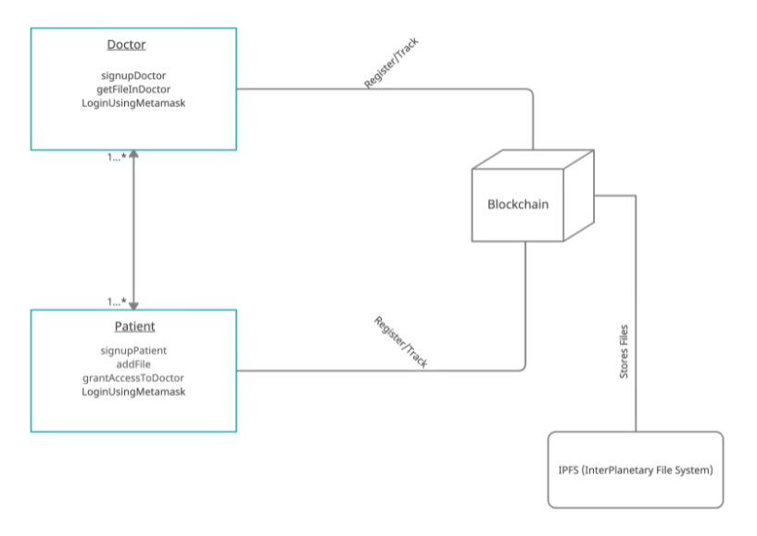

**Fig 4.1:** System Design

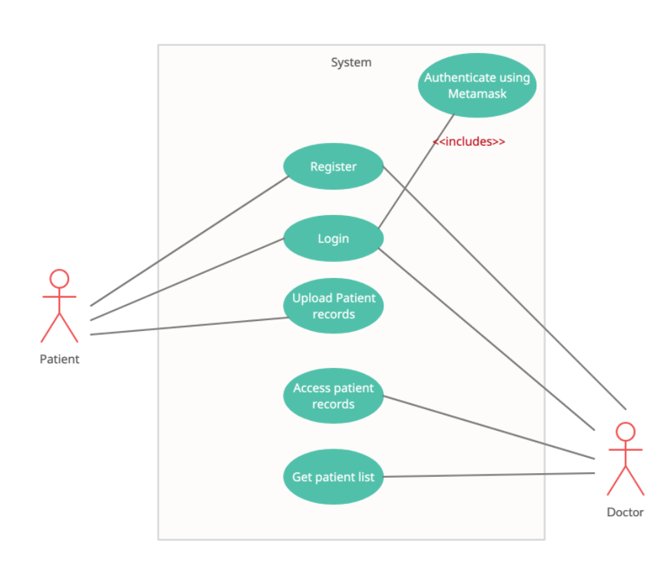

**Fig 4.2:** Use case diagram of the system

7

**Chapter 5:**

**IMPLEMENTATION**

The system was implemented by using a local blockchain made using Ganache.

**5.1 Steps Taken**

1. **Creating Smart Contracts:**

Smart contracts were written using Solidity to handle patient and doctor registration, store and retrieve health records on the blockchain. These contracts are used for granting and revoking access to the users on the DApp and performing create, read and add operations on the records of patients.

**Algorithm for the "Agent" Smart Contract:**

1. Declare the Solidity version pragma directive pragma solidity.
2. Define the contract "Agent" with the following data structures:
3. Create a function "add_agent" that takes in name, age, designation, and a hash as input and returns the agent's name.
4. Create a function "get_patient" that takes in a patient address and returns the patient's name, age, diagnosis, doctor access address, and patient record.
5. Create a function "get_doctor" that takes in a doctor address and returns the doctor's name and age.
6. Create a function "get_patient_doctor_name" that takes in a patient and doctor address and returns the patient's and doctor's names.
7. Create a function "permit_access" that permits access to a doctor's list of patients and charges 2 ether.
8. Create a function "remove_element_in_array" to remove an element from an array.
9. Create a function "remove_patient" that takes in a patient and doctor address and removes the patient's access from the doctors and doctor's access from the patient's list.
10. **Developing the user interface:**

A user interface for patients and doctors to register and login to the system was designed and implemented. It also provides functionality to help users view, create and modify health records and their access.

1. **Setting up the development environment:**

Installed and configured Ganache and MetaMask to create a local blockchain network and connected it to the user interface. IPFS was also configured.

1. **Deploying the system:**

Deploy the system to a production environment and configure it to meet the specific requirements of the users.

* 1. **Transactional Flow**

1. A new transaction being sent by a user on the blockchain network suggests that a new block is created. A block in the blockchain is used for keeping transactions in them and these blocks are distributed to all of the connected nodes in the network. That transaction placed inside a block is broadcasted to all of the nodes in the network. All the nodes in the network have a copy of the complete blockchain that helps them in the verification process. When a block containing the user transaction is broadcasted to all of the connected nodes, they verify that the block is not tampered by any means. If this verification results in success, then the nodes add that block in their own copy of the blockchain.
2. This whole process of the block being added on the blockchain is done by the nodes reaching upon a consensus where they decide which blocks are valid to be added on the blockchain and which are not. This validation is performed by the connected nodes using some known algorithms to verify the transaction and to ensure that the sender is an authenticated part of the network. When a node succeeds in performing the validation that node is rewarded with crypto-currency. This process of validating the transaction is known as mining and the node performing this validation is known as miner.
3. After validation is done that block is added to the blockchain.
4. After the whole process of validation is performed the transaction is completed.

9

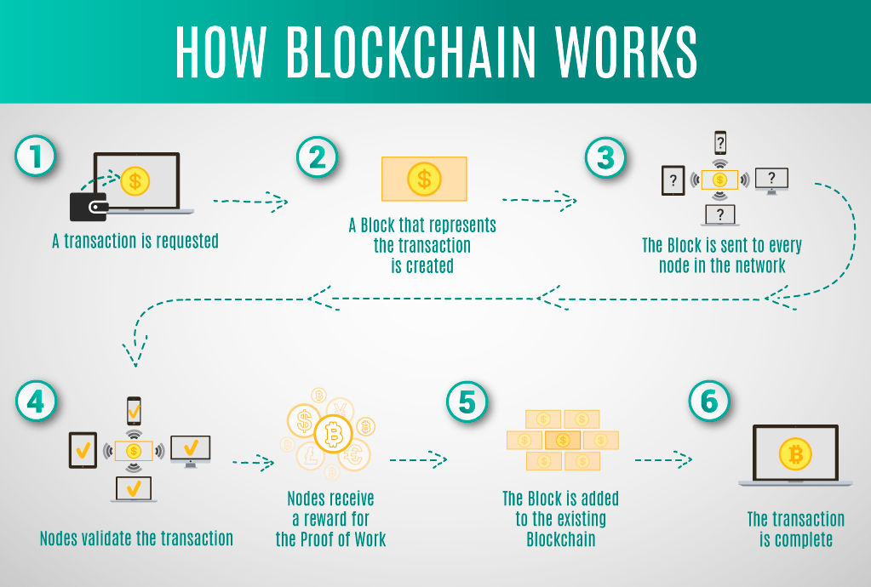

**Fig 5.1:** Overview of Blockchain Architecture

* 1. **Consensus Algorithm**

Each block that is added on the chain would need to follow some consensus rules for it to be added on the blockchain. For this purpose blockchain technology uses consensus algorithms. The most common consensus algorithm used is the Proof of Work (PoW) algorithm. The basic working of this algorithm is that there are a number of nodes or participants on a blockchain network so when a transaction is requested to be added on the network by any participating node it needs to be calculated. This process is called mining and the nodes that are performing these calculations are miners.

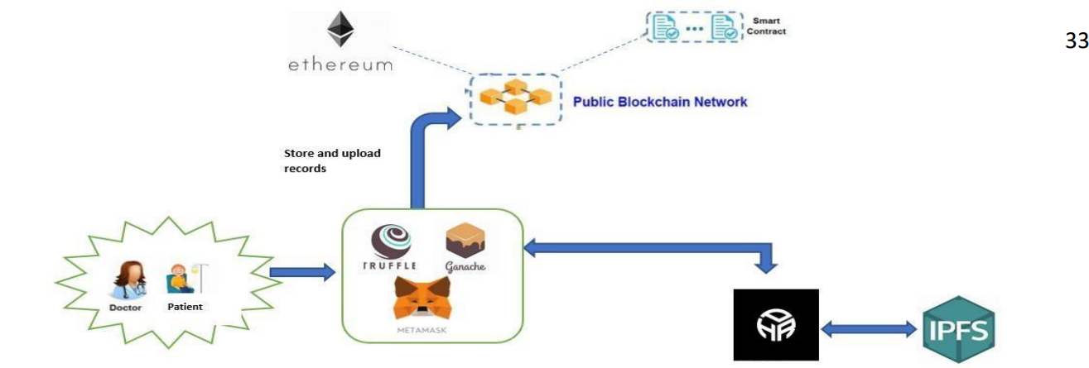

**Fig 5.2:** Protocol layer of our HER

10

**Chapter 6:**

**EXPERIMENTAL RESULTS AND ANALYSIS**

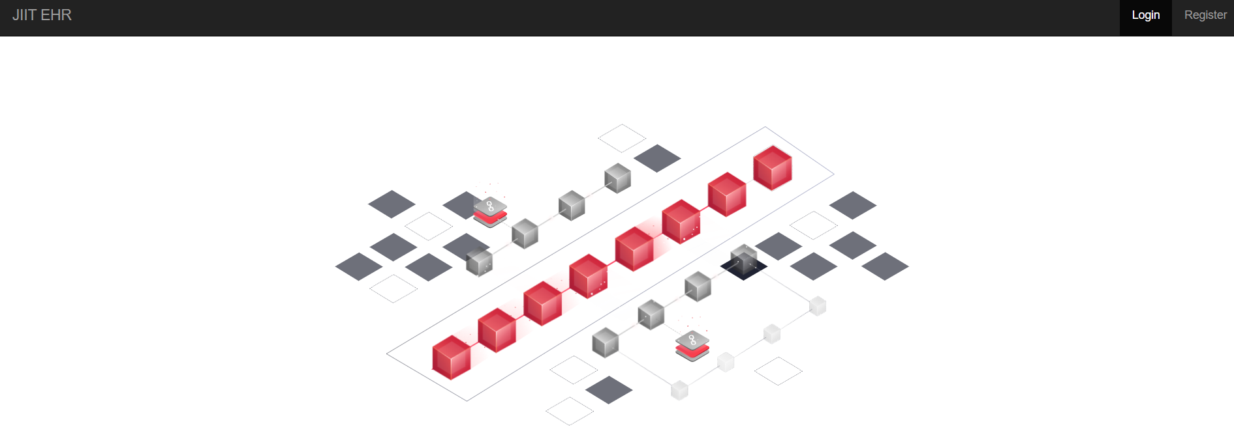

**Fig 6.1:** Home page of the software

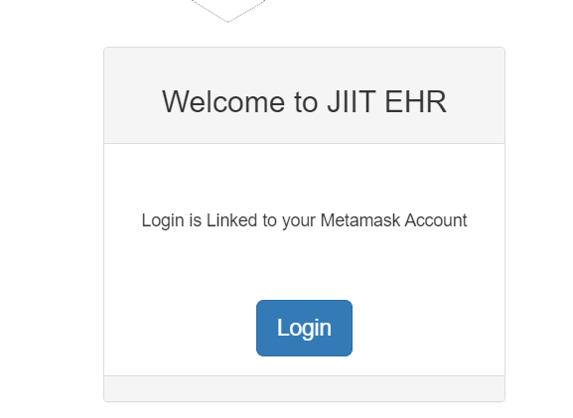

**Fig 6.2:** Login portal of the software

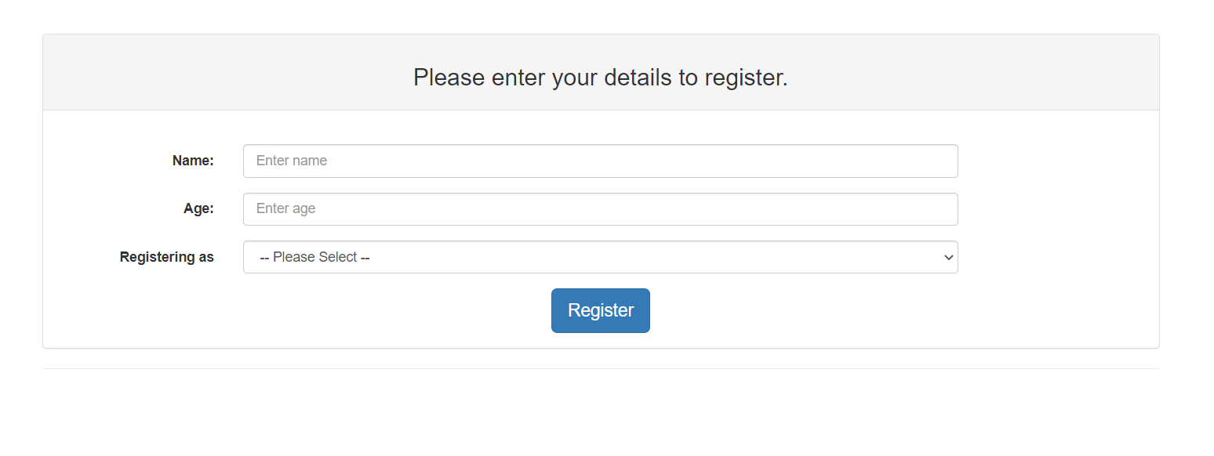

**Fig 6.3:** Register page of the software

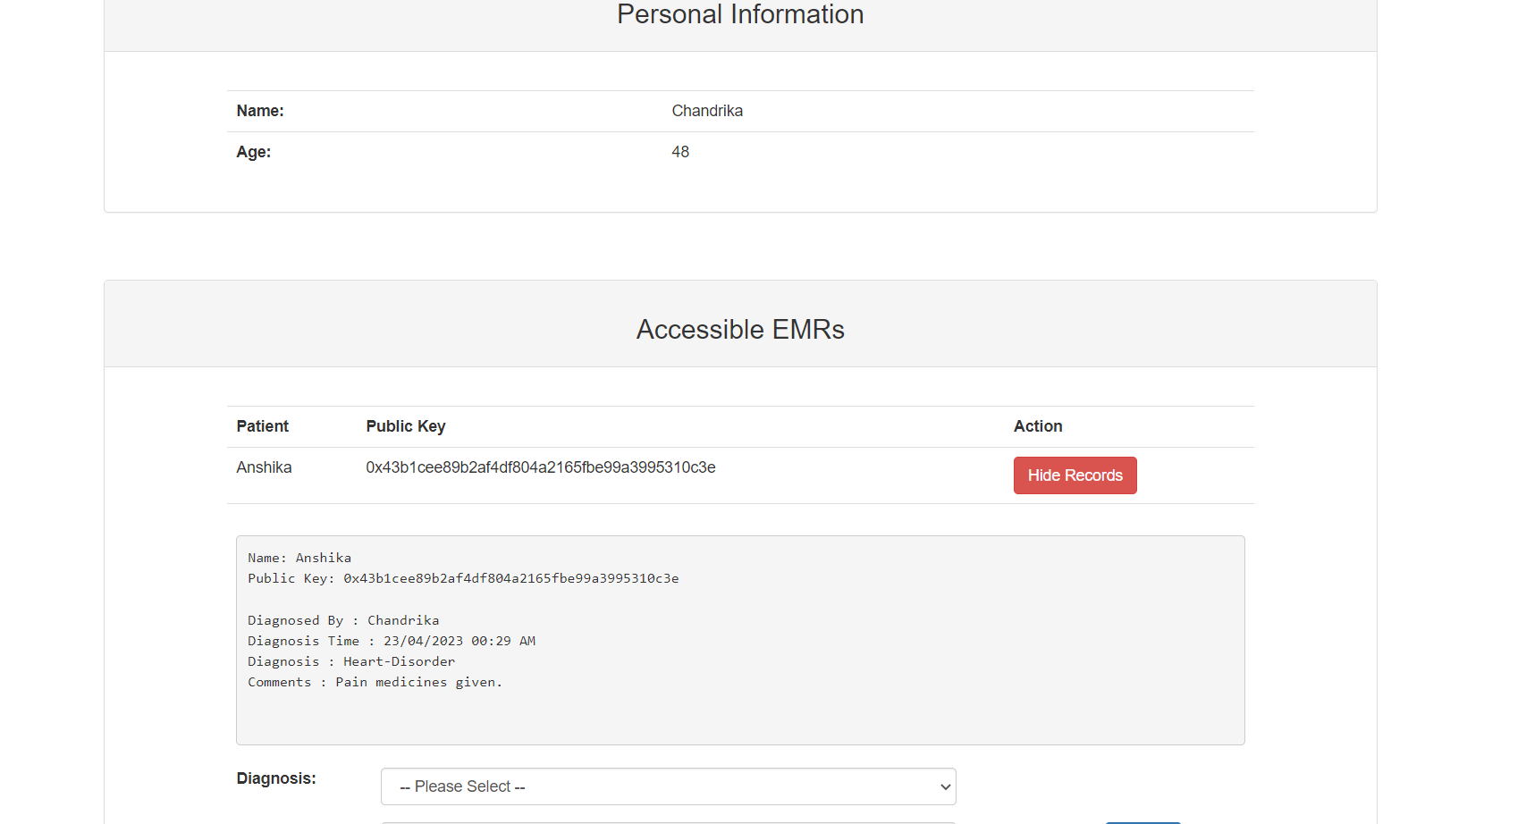

**Fig 6.4:** Dashboard for doctors

12

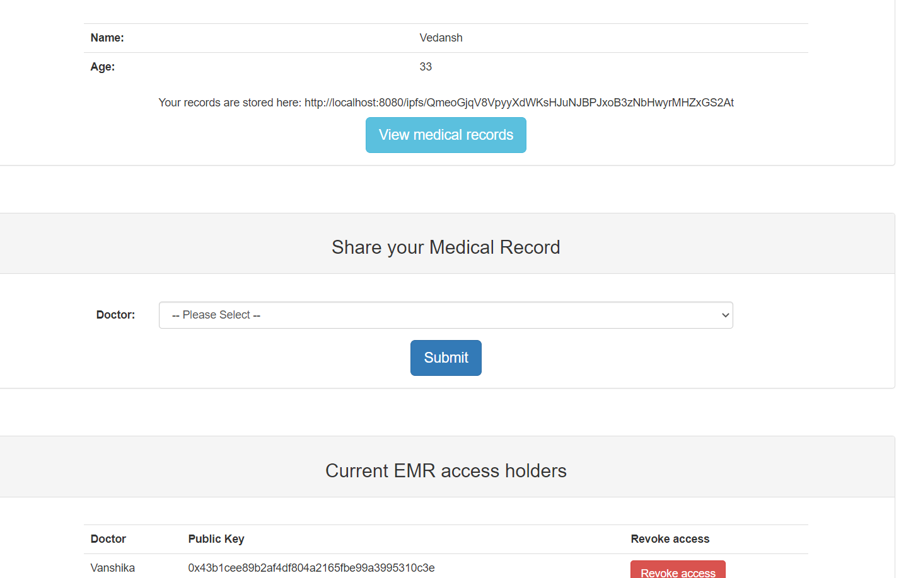

**Fig 6.5:** Dashboard for patients

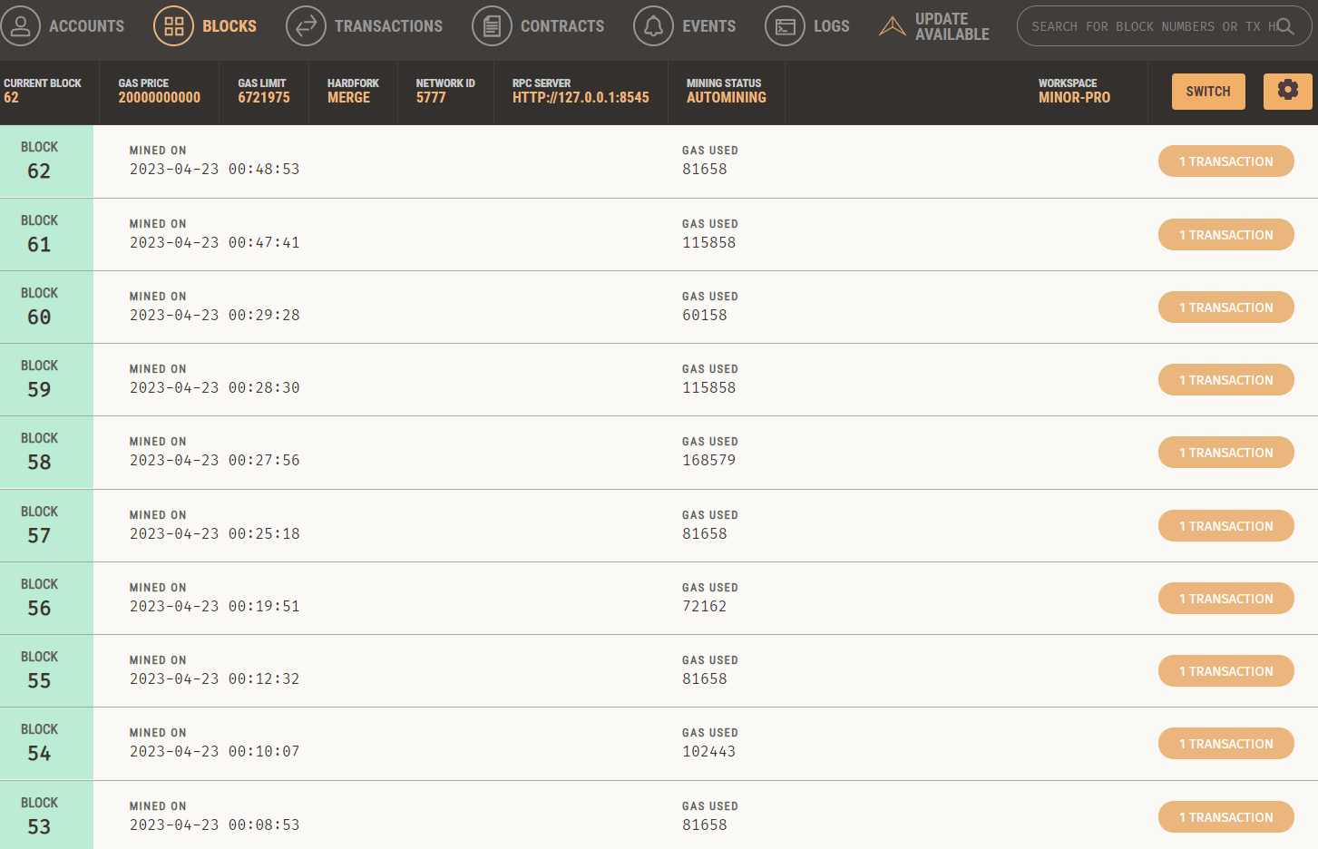

**Fig 6.6:** All previous transactions stored in blocks

13

**Chapter 7:**

**CONCLUSION AND FUTURE SCOPE**

A blockchain-based Electronic Health Record (EHR) system that utilizes Metamask, IPFS, and Ganache has several advantages over traditional EHR systems. By utilizing blockchain technology, the system provides a decentralized and secure platform for storing, managing, and sharing patient health information. The use of Metamask, IPFS, and Ganache further enhances the security, scalability, and reliability of the system. Smart contracts can automate and streamline various healthcare-related processes such as insurance claims and billing. Decentralized identity management can provide patients with full control over their personal health information, allowing them to grant access to healthcare providers and other stakeholders as desired.

The future scope of such a system is promising. As blockchain technology continues to evolve, the EHR system can be further improved as the system can be integrated with other emerging technologies such as artificial intelligence and the Internet of Things (IoT) to improve patient care and outcomes. For example, AI algorithms can be used to analyse patient health data to detect early signs of diseases, while IoT devices can gather real-time health data and transmit it securely to the EHR system for analysis and diagnosis.

In conclusion, the system developed is a secure, decentralized, and reliable platform for managing patient health information. With the potential for further improvement and integration with emerging technologies, the future scope of such a system is bright, with the potential to revolutionize the healthcare industry. A blockchain-based Electronic Health Record (EHR) system that utilizes Metamask, IPFS, and Ganache has several advantages over traditional EHR systems. By utilizing blockchain technology, the system provides a decentralized and secure platform for storing, managing, and sharing patient health information. The use of Metamask, IPFS, and Ganache further enhances the security, scalability, and reliability of the system.

**REFERENCES**

**Online**

[1] M. K. Islam, K. Islam, A. K. Biswas and R. Hasan, "Using Blockchain for Electronic Health Records," in IEEE Access, vol. 7, pp. 130820-130830, 2019, doi: 10.1109/ACCESS.2019.2930593. [Online]. Available: <https://ieeexplore.ieee.org/document/8863359>.

[2] A. Shafiee, H. S. Kim, S. Park and J. H. Kim, "Dynamic Energy Management for a PV/Wind/Battery/Fuel Cell Hybrid System Using Reinforcement Learning," in IEEE Transactions on Industrial Informatics, vol. 16, no. 11, pp. 7269-7278, Nov. 2020, doi: 10.1109/TII.2020.2984521. [Online]. Available: <https://ieeexplore.ieee.org/document/9645890/figures#figures>.

[3] A. Alsalamah, M. Alshahrani, H. Alruwaili and S. Alshammari, "A review on blockchain technology and its applications in healthcare," Journal of King Saud University - Computer and Information Sciences, vol. 32, no. 4, pp. 431-437, 2020, doi: 10.1016/j.jksuci.2019.12.015. [Online]. Available: <https://www.sciencedirect.com/science/article/pii/S138650561930526X>.

[4] M. A. Hossain, M. M. Rashid and N. Islam, "A blockchain-based architecture for secure data sharing and collaboration in mobile healthcare applications," in IEEE Access, vol. 9, pp. 61192-61206, 2021, doi: 10.1109/ACCESS.2021.3070291. [Online]. Available: <https://ieeexplore.ieee.org/document/9415996>.

[5] A. Shafiee, H. S. Kim, S. Park and J. H. Kim, "Dynamic Energy Management for a PV/Wind/Battery/Fuel Cell Hybrid System Using Reinforcement Learning," in IEEE Transactions on Industrial Informatics, vol. 16, no. 11, pp. 7269-7278, Nov. 2020, doi: 10.1109/TII.2020.2984521. [Online]. Available: <https://ieeexplore.ieee.org/document/9645890>.

15